Glossary

Robotic Vehicle Controlled By Touchscreen-Based Device

Yousef Albatel
Well Moua
Dr. Reza Khani
EECE-490AW
Engineering Design Report
January 2, 2025

Electrical and Computer Engineering Department (EECE)
California State University, Chico
Chico, CA 95929-0888

Executive Summary

The Robotic Vehicle Controlled By Touchscreen-Based Devices is a project that was proposed by Dr. Reza Khani. The project is designed to utilize a touchscreen-based device, in conjunction with radio frequency as a transmitter and receiver. In addition, two microcontrollers will be used to act based on Dr. Khani’s requirements. One microcontroller will act as a transmitter from the touchscreen-based device, while the other will be put on the robotic vehicle as the receiver. The robotic vehicle must be able to move in four directions such as moving forward, backward, left, and right having a limit range of 200 meters. In regards to the problem for this project, it was to design a robotic vehicle for police and fire departments that is able to do search and rescue missions by providing information along with putting both the departments at risk while controlling the robotic vehicle. Overall, the robotic vehicle was made to meet Dr. Khani’s requirements while a new feature was added onto the project which is having a camera attached to the robotic vehicle which the video feed will appear on the touchscreen-based device

Acknowledgements
- California State University, Chico (CSUC) 13, 14
- Electrical and Computer Engineering Department 13, 14
- Dr. Reza Khani, Faculty Advisor ii, 14

Tables of Contents
Executive Summary ii.
Acknowledgement iii.
List of Tables v.
List of Figures v.
1 Background and Introduction 1
2 Problem Definition 2-7
2.1 Customer Requirements 3
2.2 Engineer Specification 4
2.3 Targets 5-6
2.4 Success 6-7
3 Planning 7-8
4 Concepts 9
4.1 Block Diagram 9-10
4.2 Main Body 10-12
4.3 Budget 12
5 Standards 13
6 Summary and Proposed Future Actions 14
7 References 15-16

List of Figures and Tables
List of Figure
Figure 1 Fall Gantt Chart 8
Figure 2 Spring Gantt Chart 8
Figure 3 Block Diagram of Touchscreen-based device 10
Figure 4 Block Diagram of Robotic Vehicle 11

List of Tables
Table 1 Engineering Specifications Table 5

Background and Introduction
In emergency situations, particularly those involving police and fire departments, the need for quick, effective action is paramount. However, one of the major challenges these departments often face is a shortage of manpower, especially in high-risk or dangerous environments. In situations such as scouting a dangerous scene, fire rescues, or search and rescue operations in unstable structures, the safety of personnel is always a primary concern.
One potential solution to this issue is the use of robotic vehicles that can be deployed in place of human responders. These robotic vehicles are equipped to handle risky tasks and can safely navigate dangerous environments, ensuring that police officers, firefighters, and rescue personnel are not exposed to unnecessary danger. By utilizing the robotic vehicle for missions such as searching hazardous locations, locating victims, or assessing dangerous scenes, emergency responders can conserve their manpower while reducing the risk to human lives.
The robotic vehicle in question is designed to move in various directions forward, backward, left, and right via a touchscreen-based device. The vehicle operates within a range of 200 meters, making it suitable for a variety of emergency scenarios, and the design ensures that it can navigate tight spaces, hazardous conditions, and dangerous environments where human presence may not be safe.
This innovation represents a crucial step forward in the use of robotics into public safety operations. By leveraging technology like the touchscreen-controlled robotic vehicle, police and fire departments can enhance their operational efficiency, increase safety, and provide better outcomes in life-threatening situation

Problem Definition
In emergency response situations, police and fire departments are often faced with the challenge of insufficient manpower, especially in high-risk environments. These environments include hazardous fire scenes, collapsing buildings, or situations with dangerous substances, where the safety of responders is a primary concern. When responding to such emergencies, human resources can be stretched thin, and the deployment of personnel into dangerous situations increases the risk to their safety.
The shortage of manpower, combined with the inherent risks of dangerous scenarios, calls for innovative solutions that can help mitigate these challenges. One such solution is the use of robotic vehicles that can take over specific tasks, such as search and rescue missions or navigating perilous scenes, without putting human responders in harm's way. A robotic vehicle can be deployed remotely to assess a situation, search for survivors, or retrieve valuable data, thus reducing the need for human presence in dangerous zones.
The goal is to design a robotic vehicle that can be controlled remotely through a touchscreen-based device. This vehicle should be capable of moving forward, backward, left, and right, with a maximum range of 200 meters. This will allow police and fire departments to use the robotic vehicle in situations that are too risky for human responders, providing an additional source of "manpower" in critical emergencies while keeping responders safe.

Customer Requirements
The customer, in this case, consists of emergency response teams such as police and fire departments, as well as search and rescue units. They have several key requirements for the robotic vehicle:
- Mobility: The robotic vehicle should be capable of moving in multiple directions, including forward, left, right, and backward, for a distance of 200 meters.
- Touch-screen based device: The robot should be controlled via a touchscreen device to ensure ease of use and direct control over its movements. Additionally, live footage captured by the camera will be displayed on the screen.
- Range: the robot should be able to move a significant distance of 200 meters to scout the area.
- Battery Life: The robot should have sufficient battery life to allow continuous operation for at least 3 hours during missions.
- Microcontroller to receive and control the vehicle: the robotic vehicle should be connected to a microcontroller that will receive instruction from the touch screen device and move the vehicle. simultaneously, it should transmit live footage from the vehicle to the touch screen device.

Engineering Specifications
To meet the customer's requirements, the following engineering specifications are proposed:
- Weight: The total weight of the robotic vehicle (inclusive of all components, such as the transmitter, receiver, and battery) must be lightweight enough for easy deployment but sturdy enough to support its operations in emergency scenarios. Ideally, it should weigh under 10 lbs.
- Battery Life: The robot should be able to function continuously for at least 3 hours. This means the power consumption needs to be optimized for efficiency, with a battery that can support the robot’s functions for this duration without needing a recharge.
- Speed: The robot must be able to travel at speeds between 2.5 to 3 mph when moving forward. This speed range strikes a balance between quick movement and maneuverability, ensuring that the robot can efficiently cover a given area without sacrificing control.
- Range: The robot should be able to move up to 200 meters before disconnecting from the touchscreen device. This ensures that it can operate over a significant area and reach challenging locations in emergencies.
- Control Mechanism: The robot will be controlled via a touchscreen device connected to a transmitter. The transmitter will send instructions to a receiver on the robot’s end, allowing the user to control the robot through the touchscreen device accordingly. This system needs to be reliable and capable of maintaining communication within the specified range of 200 meters.

Table 1: Engineering Specifications Table
Requirements | Engineering Specification | Metrics | Method/Device | Condition | Targets
Weight | mass | lbs | scale | inclusive all parts | ??
Battery Life | watts | power and hours used | powers and hours used | continuous use | >=3 hours
Speed | mph | miles per hour | ?? | when moving forward | 2.5-3 mphs
Distance before disconnecting | meters | meters moved before disconnecting | moving the vehicle forward until it disconnects from the touch screen | continuous use | 200m

Targets
The following performance targets will ensure the robotic vehicle meets the customer’s needs:
- Weight Target: The robot's total weight (including all parts such as the receiver, transmitter, and battery) must be under 10 lbs.
- Battery Life Target: The robot should operate for a continuous period of at least 3 hours on a single charge.
- Speed Target: The robot should be able to move forward at speeds of 2.5 to 3 mph.
- Range Target: The robot must be able to maintain functionality up to 200 meters from the touchscreen control device.

How Will You Know When the Project Is Successful?
The success of the project can be measured by the following:
- reinforcement: The robot should help reduce the need for human workers in dangerous situations and in manpower shortage.
- Performance Testing: The robot must meet specific requirements like weight, battery life, speed, and range. Testing must be done to determine if they were met.
- Reliability: The robot should work consistently for long periods and in different environments without failures or disconnects. This shows it is dependable.
- Ease of Use: The touchscreen should be easy for emergency responders to use with little training. Success will be measured by how quickly users can control the robot.
- Safety and Efficiency: The robot should help reduce the number of human responders needed in dangerous situations, making missions safer and more efficient. Success will be shown by how well it reduces risk and improves results.
If the robot meets these goals, the project will be considered a success and provide a helpful tool for emergency responders.

Planning
1. Fall Gantt Chart
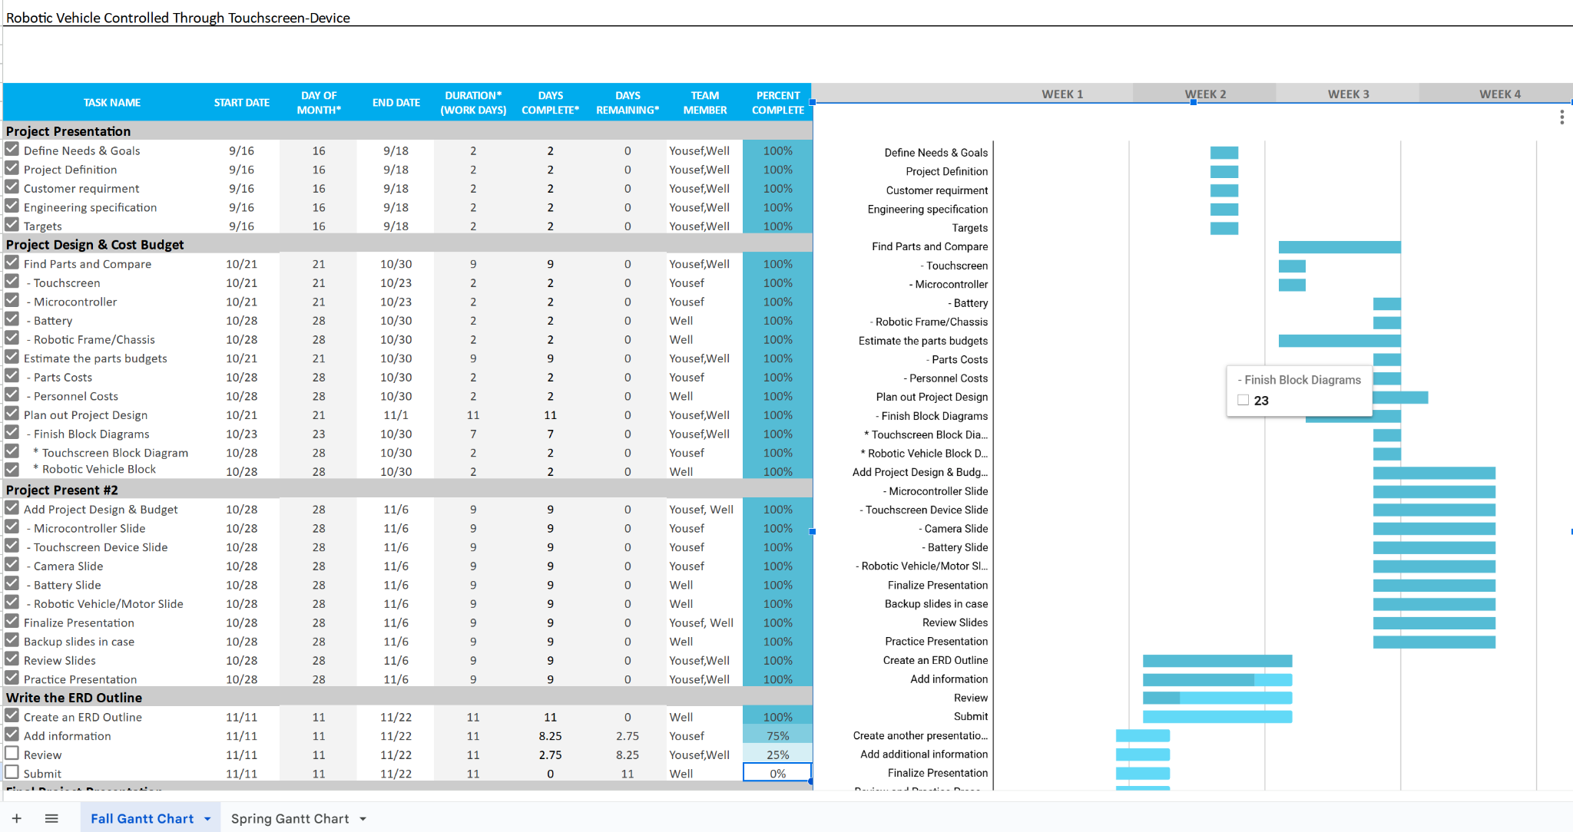
Figure 1: A layout of the fall gantt chart throughout the fall semester.
2. Spring Gantt Chart
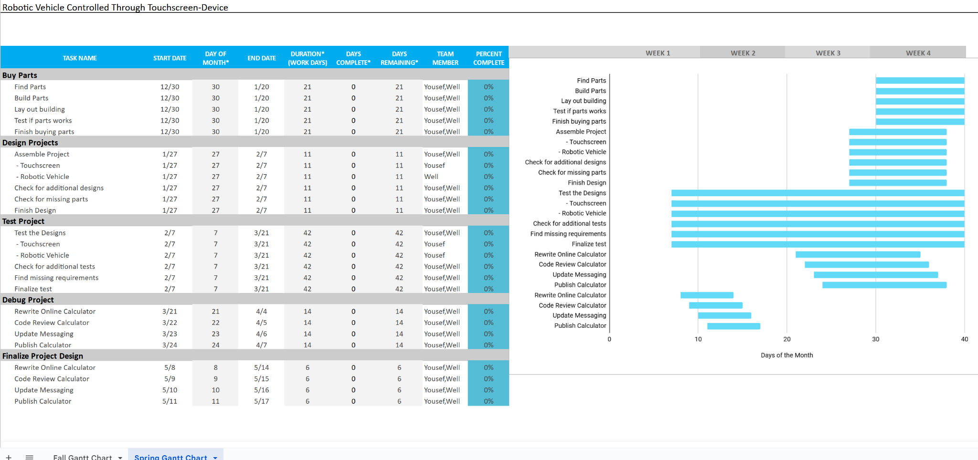Figure 2: A layout of the spring gantt chart throughout the spring semester.
According to the gantt chart, the layout of the fall gantt chart is a layout to meet the deadlines throughout the fall semester that was announced. As for the spring gantt chart, they were assumptions of what would happen within the spring semester. Once the details of the spring semester has been more detailed and explained thoroughly then updates will have to be added onto the spring gantt chart. In the gantt charts, the tasks are the huge milestones that were announced and working towards. The subtasks within the tasks are created as both team members delve deeper into the tasks. Overall, the planning was mostly followed within a timely manner and according to the gantt chart of each semester.

Concepts
In the project, the generalization of generating concepts for this project was using a mixture of concepts such as brainstorming and brainwriting. Both team members do their own research and meet up to discuss their research. After the meetups, both team members would finalize onto building the project along with some questions that would later need to be answered and researched on.
Another additional concept that was used was the use of the Go/No-Go screening which in the project certain features that would be nice to have were taken out based on both team member’s decisions and judgment. Overall, the concepts used for the project and progression were able to help the team to design the project and finalize it.

Block Diagram
3. Block Diagram of Touchscreen-Based Device (Using Wi-Fi)
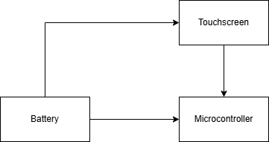
Figure 3: Block diagram of the touchscreen-based device and its major blocks.
In the above figure, this is the rough outline of what’s happening within the touchscreen-based device. In which the battery will be providing battery to the touchscreen-based device and microcontroller while the touchscreen will transmit the directions to the microcontroller.
4. Block Diagram of Robotic Vehicle (Using Wi-Fi)
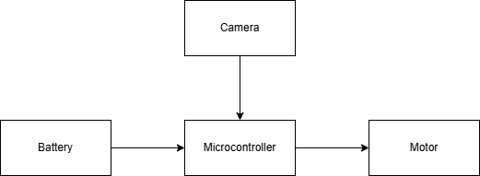
Figure 4: Block Diagram of the Robotic Vehicle and its major blocks.
In the above figure, this is also another rough outline of what’s happening within the robotic vehicle. The battery will provide a battery to the microcontroller that is on the robotic vehicle. The camera will transmit video footage to the microcontroller while the microcontroller will try to receive the movement from the touchscreen-based device to control the motor.
The two microcontrollers used are raspberry pi 4 model B microcontrollers which have a wi-fi/bluetooth chip built in. hence the two microcontrollers will connect wirelessly using wi-fi.

Main Body:
The Raspberry Pi 4 Model B is capable of handling both tasks simultaneously receiving instructions from a touchscreen device and transmitting live footage from a camera. It has enough processing power, multiple USB ports, GPIO pins, and networking options to support these functionalities without the need for an additional microcontroller.
This project uses several key components working together to create a robotic system. These components include two microcontrollers, two batteries, a touchscreen device, a robotic chassis with wheels and a motor, a camera, and a communication system. Below is an overview of how these components work together.

Chassis, Wheels, and Motor:
The robotic chassis is fitted with three wheels and a motor that allow the robot to move in different directions. The Raspberry Pi controls the movement by sending instructions to the motors. These instructions are sent from the touchscreen, enabling the robot to move forward, backward, left, and right.

Power Supply:
Two rechargeable batteries are used to power different parts of the robot. One battery powers the motors and the Raspberry Pi that controls movement, while the second battery powers the Raspberry Pi touchscreen. Both batteries are designed to last long enough for the robot to operate without frequent recharging. The Power Supply will be rechargeable for both the robotic vehicle and touchscreen-device.

Camera:
An Arducam day-night vision for raspberry pi camera will be utilized which will be mounted on the robot to capture live video. This camera works well in low-light conditions, such as smoke or darkness, thanks to its infrared capabilities. The camera streams live video to the touch screen, giving the user real-time visual feedback of the robot's surroundings.

Microcontrollers Communication:
The system uses two Raspberry Pi microcontrollers, each with a different job. The first Raspberry Pi, on the robot, controls the movement by processing commands from the touchscreen and driving the motors. It also sends live video from the camera to the touch screen. The second Raspberry Pi is connected to the touchscreen, where it sends movement commands to the robot and receives the video feed. The Raspberry Pi 4 Model B has sufficient processing power, multiple USB ports, GPIO pins, and built-in networking options (Wi-Fi and Bluetooth), is capable of handling these tasks simultaneously and effectively without the need for additional microcontrollers. The two Raspberry Pis communicate with each other over a local network, allowing the robot to be controlled and the video to be streamed in real time. We will utilize wi-fi communication because wi-fi offers a much greater range than bluetooth hence it’s more suitable for this project.

Control System:
The two Raspberry Pi microcontrollers make up the robot's control system. The first Raspberry Pi receives movement commands from the touchscreen and controls the robot’s motors while transmitting live video to the touch screen device at the same time. The second Raspberry Pi which is connected to the touchscreen device sends commands to the robotic vehicle and simultaneously receives live feed from the camera to be displayed on the screen.

Budget
The total cost for the materials is $188.95, which is well under the budget of $250. This leaves us with $61.05 remaining, which can be used for any extra parts or unexpected costs. The project is on track to stay within the budget for materials. Personnel costs, however, have not been included in this budget. If we were to account for them, the total cost would be $6,176.92, based on 12 weeks of work with 4 hours per week. As students, we did not factor in personnel costs, so the focus is on the material costs for now. The project is also meeting the engineering requirements, including battery life, speed, and distance. The materials purchased will help ensure the vehicle can run for at least 3 hours, move at speeds of 2.5 to 3 mph, and travel 200 meters before disconnecting. In addition, we want to mention thanks to the Department of Electrical and Computer Engineering from California State University, Chico for giving us the budget of $250 ($125 per student) in order to buy the parts and proceed on this project. Overall, the project is staying within budget and meeting the key technical goals.

Standards
IEEE 802.11-2016
USB-IBF - USB 2.0
USB-IBF - USB 3.0
USB-IBF - USB Type C
ANSI/CTA-861 - HDMI
802.3 - IEEE Standard for Ethernet
IEEE Std 1013TM-2019 - Battery
UART
ISO/IEC 9899 - C Language

Summary and Proposed Future Actions
In a short summary, the project was to be able to design and implement a robotic vehicle controlled by a touchscreen-based device that is able to move within 200 meters when going forward, backward, left, and right. In addition to having the touchscreen-based device act as a transmitter and the robotic vehicle to act as a receiver to move the robotic vehicle. In the future, both team members would like to implement more onto the robotic vehicle that will further its efficiency and utility. All in all, we want to give thanks to our advisor Dr. Reza Khani for overseeing this project and the California State University, Chico and the Department of Computer Engineering and Electrical Engineering for providing the budget on this project. Overall, the robotic vehicle is a project that both members believe to be a step toward a brighter future in the engineering field and world.

References
M. Mainampati and B. Chandrasekaran, "Manual and Autonomous Mode based Navigation using Human Robot Interaction on a Robotic Vehicle," 2020 11th IEEE Annual Information Technology, Electronics and Mobile Communication Conference (IEMCON), Vancouver, BC, Canada, 2020, pp. 0559-0564, doi: 10.1109/IEMCON51383.2020.9284945.

T. Auer, S. Haller-Seeber and T. Gatterer, "User Experience design of further training on Test automation of an AI self-driving robotic car powered by a Raspberry Pi," 2023 IEEE Global Engineering Education Conference (EDUCON), Kuwait, Kuwait, 2023, pp. 1-10, doi: 10.1109/EDUCON54358.2023.10125176.

Arducam, "Arducam Day and Night Camera for Raspberry Pi with Automatic IR Switching," Amazon.com, [Online]. Available: https://www.amazon.com/Arducam-Day-Night-Raspberry-Automatic-Switching/dp/B07X1VGQSL?th=1. [Accessed: Dec. 18, 2024]

GeeksforGeeks, "Difference Between Bluetooth and Wi-Fi," GeeksforGeeks, [Online]. Available: https://www.geeksforgeeks.org/difference-between-bluetooth-and-wi-fi/. [Accessed: Dec. 18, 2024]

“How to Add a Touchscreen to Your Raspberry Pi Projects.” ZDNET, www.zdnet.com/article/how-to-add-a-touchscreen-to-your-raspberry-pi-projects/. [Accessed 18 Dec. 2024]

Raspberry Pi Documentation - Display, www.raspberrypi.com/documentation/accessories/display.html. [Accessed 18 Dec. 2024]

“Robotics in Firefighting.” SFPE, www.sfpe.org/publications/fpemagazine/fpeextra/etarchives3/fpeetissue100#:~:text=Robots%20are%20being%20considered%20both,and%20search%2Dand%2Drescue. [Accessed 18 Dec. 2024]

Uclalaw. “Policing Police Robots.” UCLA Law Review, 21 Sept. 2019, www.uclalawreview.org/policing-police-robots/. [Accessed 18 Dec. 2

